Lab – Configuring Basic Router Settings with IOS CLI

1. Topology

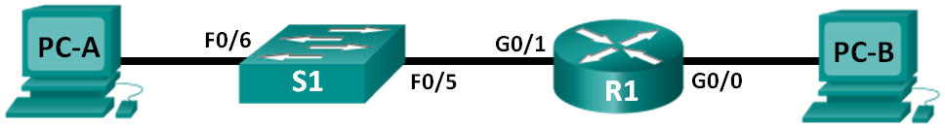

1. Addressing Table

|  |  |  |  |  |
| --- | --- | --- | --- | --- |
| Device | Interface | IP Address | Subnet Mask | Default Gateway |
| R1 | G0/0 | 192.168.0.1 | 255.255.255.0 | N/A |
|  | G0/1 | 192.168.1.1 | 255.255.255.0 | N/A |
| PC-A | NIC | 192.168.1.3 | 255.255.255.0 | 192.168.1.1 |
| PC-B | NIC | 192.168.0.3 | 255.255.255.0 | 192.168.0.1 |

1. Objectives

Part 1: Set Up the Topology and Initialize Devices

* Cable equipment to match the network topology.
* Initialize and restart the router and switch.

Part 2: Configure Devices and Verify Connectivity

* Assign static IPv4 information to the PC interfaces.
* Configure basic router settings.
* Verify network connectivity.
* Configure the router for SSH.

Part 3: Display Router Information

* Retrieve hardware and software information from the router.
* Interpret the output from the startup configuration.
* Interpret the output from the routing table.
* Verify the status of the interfaces.

Part 4: Configure IPv6 and Verify Connectivity

1. Background / Scenario

This is a comprehensive lab to review previously covered IOS router commands. In Parts 1 and 2, you will cable the equipment and complete basic configurations and IPv4 interface settings on the router.

In Part 3, you will use SSH to connect to the router remotely and utilize IOS commands to retrieve information from the device to answer questions about the router. In Part 4, you will configure IPv6 on the router so that PC-B can acquire an IP address and then verify connectivity.

For review purposes, this lab provides the commands necessary for specific router configurations.

**Note**: The routers used with CCNA hands-on labs are Cisco 1941 Integrated Services Routers (ISRs) with Cisco IOS Release 15.2(4)M3 (universalk9 image). The switches used are Cisco Catalyst 2960 with Cisco IOS Release 15.0(2) (lanbasek9 image). Other routers, switches, and Cisco IOS versions can be used. Depending on the model and Cisco IOS version, the commands available and output produced might vary from what is shown in the labs. Refer to the Router Interface Summary Table at the end of this lab for the correct interface identifiers.

**Note**: Make sure that the router and switch have been erased and have no startup configurations. Refer to Appendix A for the procedures to initialize and reload devices.

1. Required Resources

* 1 Router (Cisco 1941 with Cisco IOS Release 15.2(4)M3 universal image or comparable)
* 1 Switch (Cisco 2960 with Cisco IOS Release 15.0(2) lanbasek9 image or comparable)
* 2 PCs (Windows 7, Vista, or XP with terminal emulation program, such as Tera Term)
* Console cables to configure the Cisco IOS devices via the console ports
* Ethernet cables as shown in the topology

**Note**: The Gigabit Ethernet interfaces on Cisco 1941 ISRs are autosensing and an Ethernet straight-through cable can be used between the router and PC-B. If using another model Cisco router, it may be necessary to use an Ethernet crossover cable.

1. Set Up the Topology and Initialize Devices
   1. Cable the network as shown in the topology.
      1. Attach the devices as shown in the topology diagram, and cable as necessary.
      2. Power on all the devices in the topology.
   2. Initialize and reload the router and switch.

**Note**: Appendix A details the steps to initialize and reload the devices.

1. Configure Devices and Verify Connectivity
   1. Configure the PC interfaces.
      1. Configure the IP address, subnet mask, and default gateway settings on PC-A.
      2. Configure the IP address, subnet mask, and default gateway settings on PC-B.
   2. Configure the router.
      1. Console into the router and enable privileged EXEC mode.

Router> **enable**

Router#

* + 1. Enter into global configuration mode.

Router# **config terminal**

Router(config)#

* + 1. Assign a device name to the router.

Router(config)# **hostname R1**

* + 1. Disable DNS lookup to prevent the router from attempting to translate incorrectly entered commands as though they were hostnames.

R1(config)# **no ip domain-lookup**

* + 1. Require that a minimum of 10 characters be used for all passwords.

R1(config)# **security passwords min-length 10**

Besides setting a minimum length, list other ways to strengthen passwords.

By keeping a number in the passwords or adding a special character to the password. ____________________________________________________________________________________

* + 1. Assign **cisco12345** as the privileged EXEC encrypted password.

R1(config)# **enable secret cisco12345**

* + 1. Assign **ciscoconpass** as the console password, establish a timeout, enable login, and add the **logging synchronous** command. The **logging synchronous** command synchronizes debug and Cisco IOS software output and prevents these messages from interrupting your keyboard input.

R1(config)# **line con 0**

R1(config-line)# **password ciscoconpass**

R1(config-line)# **exec-timeout 5 0**

R1(config-line)# **login**

R1(config-line)# **logging synchronous**

R1(config-line)# **exit**

R1(config)#

For the **exec-timeout** command, what do the **5** and **0** represent?

First number, that is 5 represents minutes and second digit, that is 0 represents seconds. ____________________________________________________________________________________

* + 1. Assign **ciscovtypass** as the vty password, establish a timeout, enable login, and add the **logging synchronous** command.

R1(config)# **line vty 0 4**

R1(config-line)# **password ciscovtypass**

R1(config-line)# **exec-timeout 5 0**

R1(config-line)# **login**

R1(config-line)# **logging synchronous**

R1(config-line)# **exit**

R1(config)#

* + 1. Encrypt the clear text passwords.

R1(config)# **service password-encryption**

* + 1. Create a banner that warns anyone accessing the device that unauthorized access is prohibited.

R1(config)# **banner motd #Unauthorized access prohibited!#**

* + 1. Configure an IP address and interface description. Activate both interfaces on the router.

R1(config)# **int g0/0**

R1(config-if)# **description Connection to PC-B**

R1(config-if)# **ip address 192.168.0.1 255.255.255.0**

R1(config-if)# **no shutdown**

R1(config-if)# **int g0/1**

R1(config-if)# **description Connection to S1**

R1(config-if)# **ip address 192.168.1.1 255.255.255.0**

R1(config-if)# **no shutdown**

R1(config-if)# **exit**

R1(config)# **exit**

R1#

* + 1. Set the clock on the router; for example:

R1# **clock set 17:00:00 18 Feb 2013**

* + 1. Save the running configuration to the startup configuration file.

R1# **copy running-config startup-config**

Destination filename [startup-config]?

Building configuration...

[OK]

R1#

What would be the result of reloading the router prior to completing the **copy running-config startup-config** command?

The commands that we have typed and the steps that were performed will all be lost. ____________________________________________________________________________________

____________________________________________________________________________________

* 1. Verify network connectivity.
     1. Ping PC-B from a command prompt on PC-A.

**Note**: It may be necessary to disable the PCs firewall.

Were the pings successful? _Yes_________

After completing this series of commands, what type of remote access could be used to access R1?

We can use telnet. ____________________________________________________________________________________

* + 1. Remotely access R1 from PC-A using the Tera Term Telnet client.

Open Tera Term and enter the G0/1 interface IP address of R1 in the Host: field of the Tera Term: New Connection window. Ensure that the **Telnet** radio button is selected and then click **OK** to connect to the router.

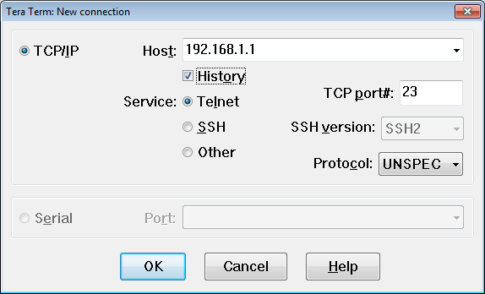

Was remote access successful? __yes________

Why is the Telnet protocol considered to be a security risk?

The configuration and passwords are visible in plain text which is a security risk. ____________________________________________________________________________________

____________________________________________________________________________________

* 1. Configure the router for SSH access.
     1. Enable SSH connections and create a user in the local database of the router.

R1# **configure terminal**

R1(config)# **ip domain-name CCNA-lab.com**

R1(config)# **username admin privilege 15 secret adminpass1**

R1(config)# **line vty 0 4**

R1(config-line)# **transport input ssh**

R1(config-line)# **login local**

R1(config-line)# **exit**

R1(config)# **crypto key generate rsa modulus 1024**

R1(config)# **exit**

* + 1. Remotely access R1 from PC-A using the Tera Term SSH client.

Open Tera Term and enter the G0/1 interface IP address of R1 in the Host: field of the Tera Term: New Connection window. Ensure that the **SSH** radio button is selected and then click **OK** to connect to the router.

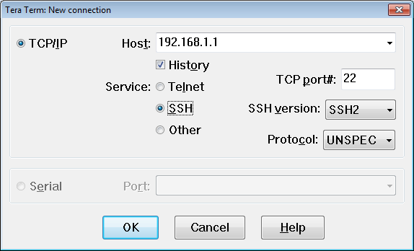

Was remote access successful? __yes________

1. Display Router Information

In Part 3, you will use **show** commands from an SSH session to retrieve information from the router.

* 1. Establish an SSH session to R1.

Using Tera Term on PC-B, open an SSH session to R1 at IP address 192.168.0.1 and log in as **admin** with the password **adminpass1**.

* 1. Retrieve important hardware and software information.
     1. Use the **show version** command to answer questions about the router.

What is the name of the IOS image that the router is running?

flash0:c1900-universalk9-mz.SPA.151-1.M4.bin ____________________________________________________________________________________

How much non-volatile random-access memory (NVRAM) does the router have?

255K bytes ____________________________________________________________________________________

How much Flash memory does the router have?

249856 ____________________________________________________________________________________

* + 1. The **show** commands often provide multiple screens of outputs. Filtering the output allows a user to display certain sections of the output. To enable the filtering command, enter a pipe (**|**) character after a **show** command, followed by a filtering parameter and a filtering expression. You can match the output to the filtering statement by using the **include** keyword to display all lines from the output that contain the filtering expression. Filter the **show version** command, using **show version | include register** to answer the following question.

What is the boot process for the router on the next reload?

0x2102. Router will boot normally. It will load ios from dlash memory. Startup config will be loaded from the nvram if it Is present. The router bypasses the startup config if register file is 0x2142. If initial boot is not successful then rommon mode is entered. ____________________________________________________________________________________

____________________________________________________________________________________

____________________________________________________________________________________

* 1. Display the startup configuration.

Use the **show startup-config** command on the router to answer the following questions.

How are passwords presented in the output?

All the passwords are encrypted. Line con password is password 7 0822455D0A160B0713181F and vty password is password 7 0822455D0A1613030B1B0D1739 ____________________________________________________________________________________

____________________________________________________________________________________

____________________________________________________________________________________

Use the **show startup-config | begin vty** command.

What is the result of using this command?

Error message displayed __

R1#show startup-config | begin vty

^

% Invalid input detected at '^' marker. __________________________________________________________________________________

____________________________________________________________________________________

* 1. Display the routing table on the router.

Use the **show ip route** command on the router to answer the following questions.

What code is used in the routing table to indicate a directly connected network?

C is used to show connected. _______________________________________________________________________________________

How many route entries are coded with a C code in the routing table? 2__________

* 1. Display a summary list of the interfaces on the router.

Use the **show ip interface brief** command on the router to answer the following question.

What command changed the status of the Gigabit Ethernet ports from administratively down to up?

No shutdown command ____________________________________________________________________________________

1. Configure IPv6 and Verify Connectivity
   1. Assign IPv6 addresses to R1 G0/0 and enable IPv6 routing.

**Note**: Assigning an IPv6 address in addition to an IPv4 address on an interface is known as dual stacking, because both the IPv4 and IPv6 protocol stacks are active. By enabling IPv6 unicast routing on R1, PC-B receives the R1 G0/0 IPv6 network prefix and can autoconfigure its IPv6 address and its default gateway.

* + 1. Assign an IPv6 global unicast address to interface G0/0, assign the link-local address in addition to the unicast address on the interface, and enable IPv6 routing.

R1# **configure terminal**

R1(config)# **interface g0/0**

R1(config-if)# **ipv6 address 2001:db8:acad:a::1/64**

R1(config-if)# **ipv6 address fe80::1 link-local**

R1(config-if)# **no shutdown**

R1(config-if)# **exit**

R1(config)# **ipv6 unicast-routing**

R1(config)# **exit**

* + 1. Use the **show ipv6 int brief** command to verify IPv6 settings on R1.

If no IPv6 address is assigned to G0/1, why is it listed as [up/up]?

Because we have given the command no shutdown ____________________________________________________________________________________

____________________________________________________________________________________

* + 1. Issue the **ipconfig** command on PC-B to examine the IPv6 configuration.

What is the IPv6 address assigned to PC-B?

IPv6 Address....................: 2001:DB8:ACAD:A:250:FFF:FE06:45D8/64

____________________________________________________________________________________

What is the default gateway assigned to PC-B? Default Gateway.................: FE80::1 ____________________

Issue a ping from PC-B to the R1 default gateway link local address. Was it successful? __yes________

Issue a ping from PC-B to the R1 IPv6 unicast address 2001:db8:acad:a::1. Was it successful? _yes _______

1. Reflection
   1. In researching a network connectivity issue, a technician suspects that an interface was not enabled. What **show** command could the technician use to troubleshoot this issue?

_show ip interface brief ______________________________________________________________________________________

* 1. In researching a network connectivity issue, a technician suspects that an interface was assigned an incorrect subnet mask. What **show** command could the technician use to troubleshoot this issue?

Show running config _______________________________________________________________________________________

* 1. After configuring IPv6 on the R1 G0/0 PC-B LAN, if you were to ping from PC-A to the PC-B IPv6 address, would the ping succeed? Why or why not?

It will not ping because we have assigned ipv6 address to noly one interface that is g0/0 and not on g0/1. _______________________________________________________________________________________

_______________________________________________________________________________________

1. Router Interface Summary Table

|  |  |  |  |  |
| --- | --- | --- | --- | --- |
| Router Interface Summary | | | | |
| Router Model | Ethernet Interface #1 | Ethernet Interface #2 | Serial Interface #1 | Serial Interface #2 |
| 1800 | Fast Ethernet 0/0 (F0/0) | Fast Ethernet 0/1 (F0/1) | Serial 0/0/0 (S0/0/0) | Serial 0/0/1 (S0/0/1) |
| 1900 | Gigabit Ethernet 0/0 (G0/0) | Gigabit Ethernet 0/1 (G0/1) | Serial 0/0/0 (S0/0/0) | Serial 0/0/1 (S0/0/1) |
| 2801 | Fast Ethernet 0/0 (F0/0) | Fast Ethernet 0/1 (F0/1) | Serial 0/1/0 (S0/1/0) | Serial 0/1/1 (S0/1/1) |
| 2811 | Fast Ethernet 0/0 (F0/0) | Fast Ethernet 0/1 (F0/1) | Serial 0/0/0 (S0/0/0) | Serial 0/0/1 (S0/0/1) |
| 2900 | Gigabit Ethernet 0/0 (G0/0) | Gigabit Ethernet 0/1 (G0/1) | Serial 0/0/0 (S0/0/0) | Serial 0/0/1 (S0/0/1) |
| **Note**: To find out how the router is configured, look at the interfaces to identify the type of router and how many interfaces the router has. There is no way to effectively list all the combinations of configurations for each router class. This table includes identifiers for the possible combinations of Ethernet and Serial interfaces in the device. The table does not include any other type of interface, even though a specific router may contain one. An example of this might be an ISDN BRI interface. The string in parenthesis is the legal abbreviation that can be used in Cisco IOS commands to represent the interface. | | | | |